Kavya Gundala

23-12-2023

**Basic Spark Commands:**

* To start Spark Shell,

Spark-shell

* Read the file from local system,

Val data = sc.textFile(“data.txt”)

“sc” is the spark context.

* Create RDD through parallelizing,

Val num = Array(1,2,3,4,5,6,7,8,9,10)

Val NewData = sc.parallelize(num)

* Count items in RDD,

NewData.count()

* To read the first 5 items from RDD,

NewData.take()

NewData.take(2) -> gives first 2 items from RDD

* Save output/processes data into the text file,

Counts.saveAsextFile(“output”)

Here “Output” folder is the current path.

**Intermediate Spark Commands:**

* Filter on RDD,

Let’s create a new RDD for items that contain “yes”.

Val DFData = data.filter(line=&gt;line.contains(“yes”))

To apply the transformation filter to an existing RDD and generate a new listof items, you must filter for the word “yes”.

* Chain operation,

Data.filter(line=&gt;line.contains(“DataFlair”)).count()

* Create RDD through parallelizing,

Val num = Array(1,2,3,4,5,6,7,8,9,10)

Val NewData = sc.parallelize(num)

NewData is the RDD now

* Count RDD partitions,

NewData.partitions.length

* Cache a file,

data.cache()

**Functions of Spark:**

* Read,

cases = spark.read.load(“path”, format=”csv”, sep = “,”), inferSchema =”true”,header=”true”

* See rows in the file,

cases.show()

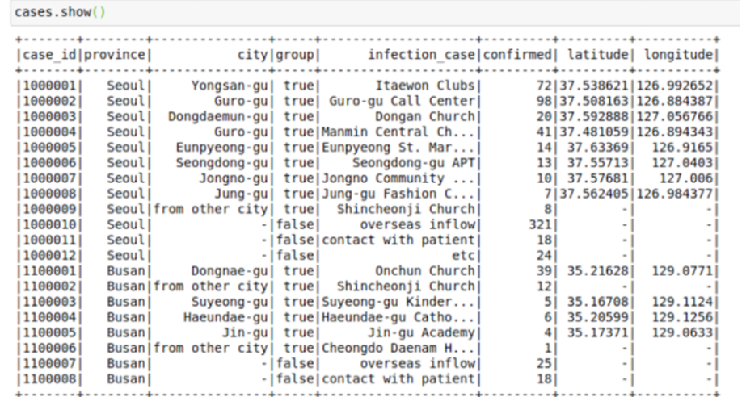

Cases.limit(10).toPandas(),

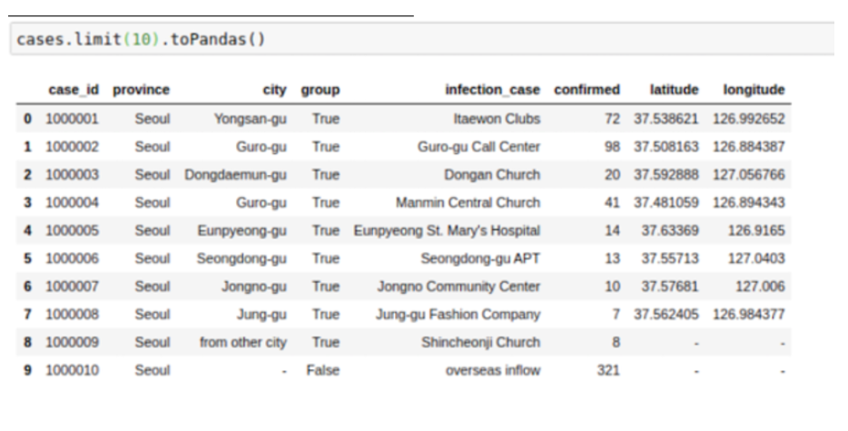

* To Change Column names,

To change the name of columns in Spark Dataframes:

Cases= cases.withColumnRenamed(“Infection_case”,”Infection_source”)

For all Columns:

Cases=cases.toDF(*[‘case_id’,’province’,’city’,’group’,’infection_case’,’longitude’])

* Select columns,

Cases=cases.select (‘province’,’city’’infection_case’,’confirmed’)

Cases.show() -> shows entire table

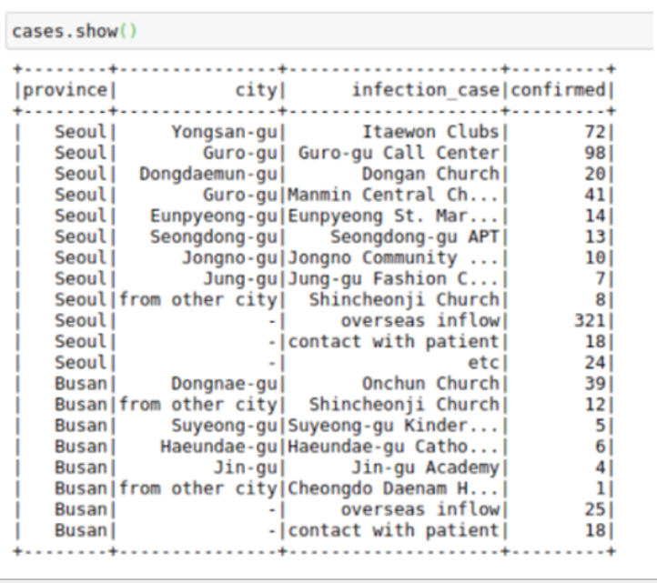

* Sort,

Cases.sort(‘confirmed’).show()

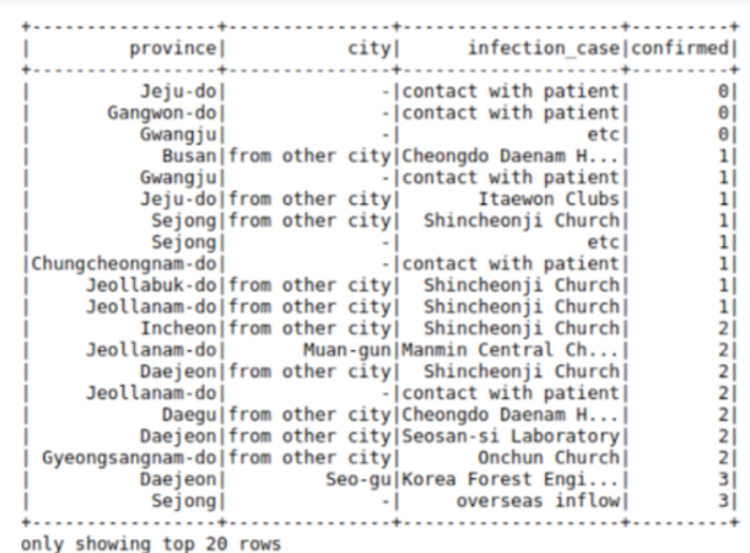

* From pyspark.sql import Functions as F

Cases.sort(F.desc(“confirmed”)).show()

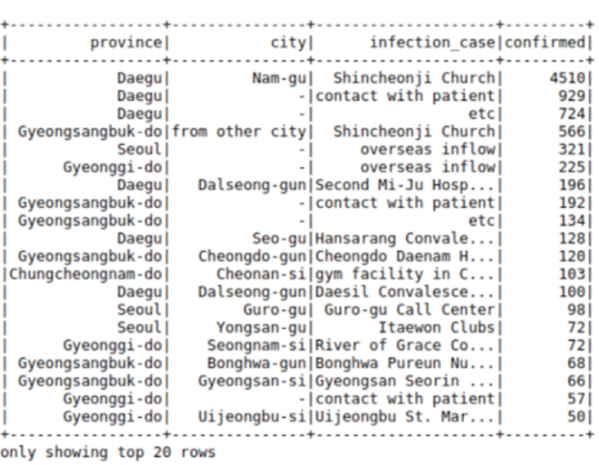

* Cast,

From pyspark.sql.types import DoubleType, IntegerType, StringType

cases = cases.withColumn(‘confirmed’, F.col(‘confirmed’).cast(IntegerType()))

cases = cases.withColumn(‘city’, F.col(‘city’).cast(Stringtype()))

* Filter,

cases.filter((cases.confirmed>10)&(cases.province==’Daegu’)).show()

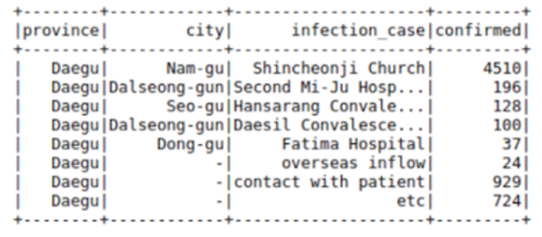

* Groupby,

From pyspark.sql import funcitons as F

cases.groupBy((“province”,”city”)).agg(F.sum(“confirmed”),F.max(“confirmed”)).show()

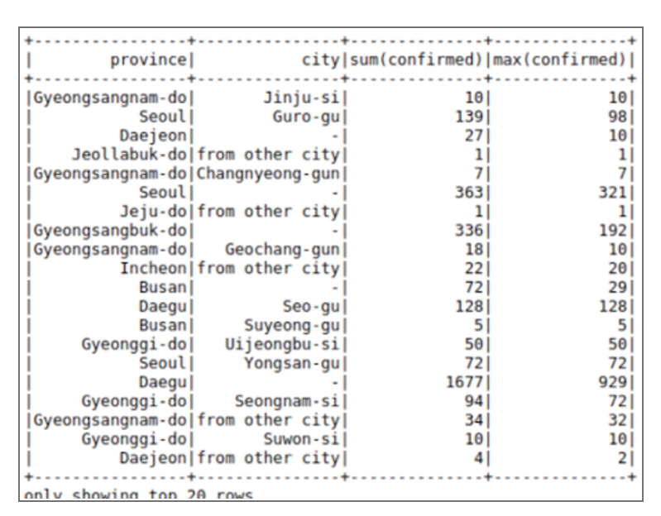

If we don’t like the new columns, we can use alias keyword to rename columns in the command itself,

cases.groupBy([“province”,”city”]).agg(

F.sum(“confirmed”).alias(“TotalConfirmed”),\

F.max(“confirmed”).alais(“MaxFromOneConfirmedCase”).show()

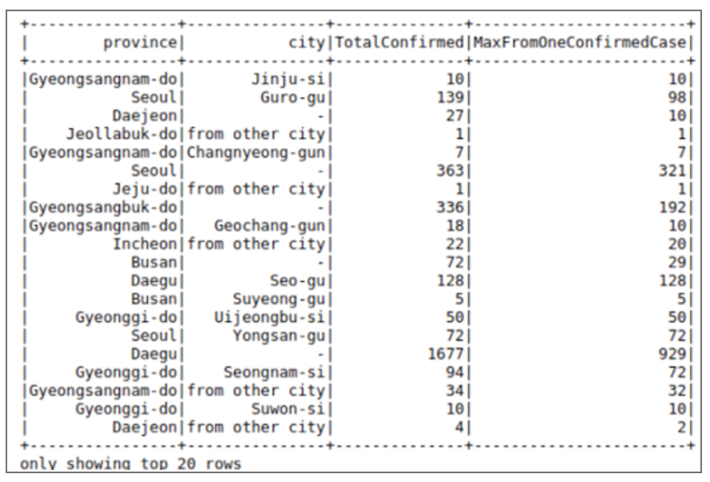

* Joins,

regions = spark.read.load(“Path”,format=”csv”, sep=”,”, inferSchema=”true”, header=”true”)regions.limit(10).toPandas()

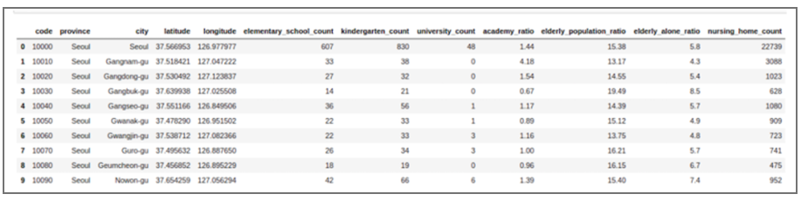

* cases= cases.join(regions,[‘province’,’city’], how=’left’)

cases.limit(10).toPandas()

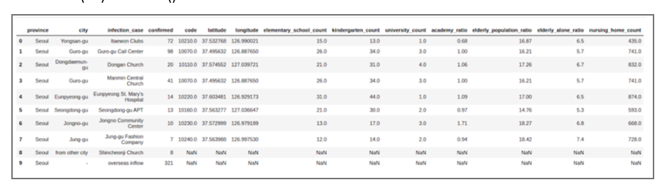

* Broadcast/Map side joins in pyspar Dataframes

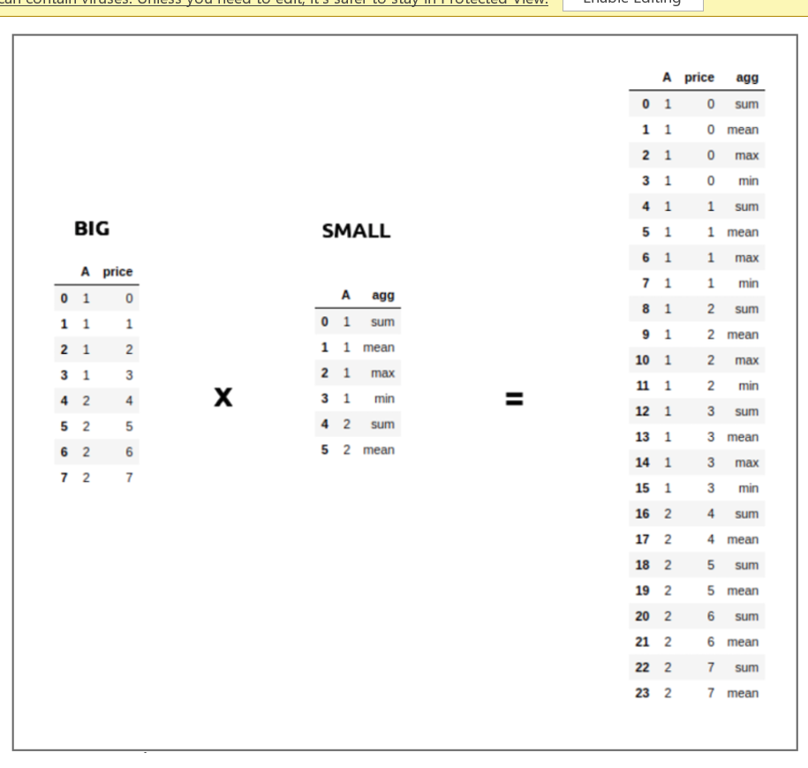

from pyspark.sql.functions import broadcast

cases = cases.join(broadcast(regions),[‘province’,’city’], how = ‘left’)

* Use sql with pyspark dataframes

cases.registerTempTable(‘cases_table’)

newDF = sqlContext.sql(‘select* from cases_table where confirmed>100’)

newDF.show()

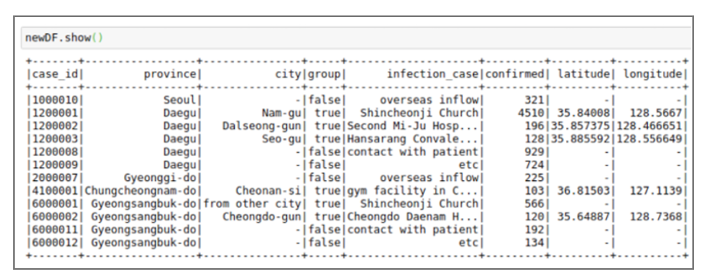

* Create new columns in pyspark dataframes  
  using spark native commands

Import pyspark.sql.functions as F

casesWithNewConfirmed = cases.withColumn(“NewConfirmed”,100+F.col(“confirmed”))

casesWithNewConfirmed.show()

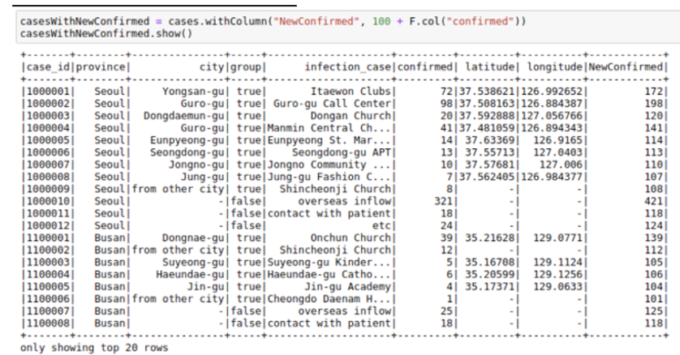

We can also use math funcitons like the F.exp function :

casesWithExpConfirmed = cases.withColumn(“ExpConfirmed”,F.exp(“cofirmed”))

casesWithExpConfirmed.show()

